Newport versus Woolies
Read here highlights from the very active and articulate “NewPort (NSW) versus Woolies Community Group” campaign against a very largely unwanted Woolworths: except for the Council and Woolworths. Also follow the fight on www.newport.org.au and www.newportversuswoolies.org

We need your help yet again!

Current situation
We’ve all spent time and energy in getting the Woolworths proposal knocked back. A huge number, 2,565 of you, in fact, sent in submissions to the Council objecting. Over 5,000 people have signed the petition against a mega store in Newport. Pittwater Council’s own consultants rejected the Woolworths plan.

But Pittwater Council has ignored all this, has ignored its own community and voted for an “alternative” plan to bring about the rezoning of our public land.

Behind this alternative rezoning proposal is a deal made by Pittwater Council with Woolworths. If the rezoning is approved by the State Planning Department, a further condition of the Council/Woolworths deal is satisfied.

This is an outrageous situation and we believe should be the subject of a public hearing. It is a cynical exercise by a local Council, which has no ethical or moral right to act the way it has.

So we are now asking you to send in a further submission, this time to the NSW department of Planning, care of Pittwater Council, which is collecting the submissions. Submissions close soon, on 10 February.

This “alternative” rezoning proposal comes without any prior consultation with the community whatsoever. It’s public land at stake here, so if any rezoning were to take place, a clear community benefit should at least be guaranteed.

What are we trying to achieve?

What do we really want for Newport? Well, we want a quality development that will be the heart of Newport’s own off main road village area. A massive development covering the site from edge to edge won’t give us this result. We know that developments with some trees, open green space can give us this character. Since this is public land, we also expect some actual community use – for example a library annex or child minding centre. Then we would be talking about an asset to Newport, a great community place that would give Newport the off main road identity the village needs.

Now, what about the commercial aspects of a development on this site? For one thing, the original brief to intending developers talked about having council offices on the site. This was forgotten when Woolworths came onto the scene, but the rationale was to sell the Vuko Rd Council offices (said to be worth $7-10m) and relocate on Foamcrest. That would be a huge contribution to Newport businesses, especially at lunch time when local businesses say things are pretty quiet. The site is big enough to include a modest sized supermarket, retail and offices. There could be some apartments as well. What is being requested here is not in any way unreasonable and, may be found in other developments in other parts of Sydney.

Please write to the Department of Planning, telling them we want trees, open space and community use guaranteed should any rezoning occur on this site and that the current “alternative” plan is unacceptable.

Why is Pittwater Council doing this? Here are some opinions we have heard around Newport on that subject:

- The Council lost money in the GFC by investing in junk bonds. They have a shortfall they want to satisfy with the Woolworths sale.
- The costs of the Council are enormous. The general manager gets paid more than the Premier of NSW and almost as much as the Prime Minister of Australia.

Note here that the “deal” with Woolworths to sell the whole Foamcrest Ave site for $4.55m seems to be a very poor (and naive) deal indeed. Yet another government department playing at big business.

We have requested to see the conditional contract between Woolworths and the Council. They have refused. We are appealing this refusal.

Points you may like to raise in your submission to the Department of Planning

- This “alternative” plan is a blanket commercial rezoning and that is wrong. The rezoning of public land must show a public benefit. Any rezoning must include provision for trees etc as green open space, and possible community uses such as a library annex, childminding etc

- This land should not be rezoned to accommodate an undisclosed conditional contract between the Council and Woolworths. The Woolworths plan has been rejected by independent consultants because it did not comply with the Newport Masterplan, particularly in covering the entire site from edge to edge, allowing for no community, trees or green space.

- Newport is a place of natural beauty that should not be downgraded. A sensitive, quality development would be welcomed. It would help create an off-main road centre that would become the heart of our village. This is Newport’s last chance to create this off main road area, linking to a future Robertson Road pedestrian plaza.

- We need a vibrant commercial/retail/residential development that could include Pittwater Council offices if the council’s outmoded Warriewood offices were sold. Newport already has many creative businesses – architects, designers etc that should be encouraged in any new development.
Could we suggest you select the 4 points above and copy into an email, adding your own comments to
pittwater_council@pittwater.nsw.gov.au

Alternatively. you could copy into Word, then add your own comments as a personal submission. Or simply write your own submission as you see it.

Your submission should be headed “Rezoning No R0001/09” and addressed to the NSW Dept of Planning, care of Pittwater Council, Park Street Mona Vale 2103. You should also provide your name and address and phone number.
Websites: www.newport.org.au and www.newportversuswoolies.org
14th October 2010
Come to Monday night’s Council meeting!

Pittwater Council is trying to rezone our public land by the back door

SJB Planning, the independent consultants employed by Pittwater Council, have rejected Woolworths scheme. They say it is “inconsistent with the provisions of the Newport Village Commercial Centre Masterplan “

Now that should mean that Woolworths proposal and conditional contract to buy our public land has failed. However, in what appears to be a desperate move to get the Woolworths proposal over the line, the Council has asked the consultants to present an alternative rezoning application recommending rezoning!

If this alternative rezoning is accepted, the Woolworths deal will go to the next stage.

How can this be fair or acceptable practice?

Throughout, it seems to us there has been an administrative cloud over the Woolworths/Council deal. We believe the Council has a conflict of interest in this matter. We have in fact instructed lawyers to provide legal advice. We have also made an initial complaint to the NSW Ombudsman and will be making a comprehensive report to the Local Government Department.

What should happen now?

If you or I were bringing this rezoning application, it would now be dead in the water, but the Council seems determined to keep the contract with Woolworths alive.

Quite simply, before any “deal” was done with Woolworths, Pittwater Council should have put forward its own rezoning application based on a strategic planning assessment and proper consultation with the community.

The Council is pretending the alternative planning application in its report is all that’s necessary. It’s not. It’s also grossly wrong that the community have spent an enormous amount of time and money on considering Woolworths various “concept” plans and are now being told that a plan tacked onto a failed proposal will go ahead.

We must not let the Council rezone our public land for Woolworths benefit

Don’t let this injustice happen.

Pittwater Council has lost its way. It’s trying – badly - to be a big business operator, but it’s not there for big business, it’s there to represent the people of its electorate. Literally thousands have said they don’t want the big business deal the Council is trying to push. Now the Council’s own consultants have recommended the deal should be rejected.

Look at future possibilities

If a correct and proper planning appraisal of the carpark site is carried out, we could have a wonderful development on this site. Many excellent designs have been suggested by local architects and designers.

Don’t let Woolworths build their mega store. This will destroy the character, charm and quality of Newport village. It will leave no off-main road area at all in Newport. Don’t let our village become a supermarket depot, with Barrenjoey Road and back streets choked with pollution, noise and traffic.
We must show we want something better for Newport. This is Newport's last chance!
Please come to the meeting this Monday night, 18 October, 6.30 pm at the Mona Vale Memorial Hall.
Website: www.Newportveruswoolies.org
16th August 2010
It’s a record!
The huge number of submissions objecting to the very latest Woolworths’ proposals was an all time record! So many, in fact, that the Pittwater Council website crashed! Our very sincere thanks to all those Newport residents who wrote to the council pleading for a better development.

1,185 submissions were received, 98% of which were against Woolworths mega store.

These 1,185 submissions were in addition to over 1,300 received on Woolworths earlier proposals. Pittwater Council have stated that many of the submissions were form letters. This suggests submissions were not personal which is just not true. Seventy percent (70%) contained personal comments or longer detailed professional and other submissions. Those who had submitted our list of points against the development had provided their name, address and telephone number and mailed or personally delivered their letter to the council offices as their own objection. Never before have so many submissions been received on a local development.

The Newport Residents Association and the Newport versus Woolies Community Group believe it is important that residents know about the latest submissions and fortunately printed out all 1,185 before the website crashed.

What stronger message can we send to Pittwater council that we just don’t want this abominable development?

Yet we understand Pittwater Council still want to proceed and we ask Why???

- Why would a council that opposes the Meriton development in Warriewood want overdevelopment in Newport?

- Why would a council that has spent a fortune on espousing its sustainability and environmental credentials want to support a development that destroys open space and turns Newport into the worst sort of traffic ridden urban nightmare.

- Why would a council that upheld the wishes of Newport residents in the past in preserving open space public land want to ignore residents and ruin the village centre of Newport by selling off public land.

- Why would a council be so short sighted to take on a development that downgrades the village, reduces property prices and eventually reduces rates income when alternatives would give an excellent initial return anyway.

- Why would a council that has just spent millions landscaping Newport now want to impose this brutal development on us?

- Why would a council that has produced a Masterplan in consultation with residents now want to go against the very spirit and letter of this Masterplan.

There are many unanswered questions here. Is it true that the only thing the management of Pittwater Council are interested in is a cash payment – and not a very good one at that – for our public land?

Did the council organisers of this scheme make some sort of deal with Woolworths they cannot get out of? The council have not revealed any documentation for this deal, but it certainly is something we’d all like to see.

And why should there be any deal with a private corporation in the first place? Why wouldn’t the council put up the rezoning proposal for public comment before any “deal” with any private corporation were entered into?

Pittwater Councillors have sound, practical, community, environmental and plain common sense reasons to vote against the rezoning of our public land.

Newport people have made it completely and utterly clear they don’t want a mega store in their village. And it’s not just these latest submissions. More than 5,000 people who have signed the petition saying they don’t want this giant store.

We ask councillors to consider these 10 critical points:

- Newport’s strength lies in the potential character of this small village. Newport needs an off main road village centre to avoid becoming a 1960’s style traffic strip. Keeping the north council carpark and part of the south carpark on Foamcrest Ave as community space is vital to enable a proper link up with Robertson Road to become the hub of an attractive new village centre.

- This style and character issue is vital for all of Pittwater. The strong tourist appeal of the collection of villages north of Mona Vale must not be downgraded by a Parramatta Road style Mega store in Newport.

- Some of Australia’s best architects and designers have put up alternative plans that would work for everyone. There can be a great development on this site that will bring this end of Newport to life. It would provide parking, a variety of shops including a modest sized supermarket but most importantly it would include green space that’s people friendly and to a human scale.

- We repeat the alternative plans put forward do not preclude a small supermarket. Woolworths want to take over our public land to create a mega store to dominate local trade, when in fact there is no reason why they should not build a modest supermarket on their own land.

- Councillors and Staff are completely supported in rejecting this proposal by the provisions of the Newport Masterplan. The essential point here is that the Woolworths plan, while ticking some of the Masterplan boxes in a superficial way, is dead against the spirit and many of the actual provisions of the Masterplan. This is about planning for the future for the people who live in Newport, not about satisfying a greedy, profit hungary corporation

- In the view of residents groups, the council has become involved in a broader corporate battle that ignores the environmental, social, cultural and community values of Pittwater. The duopoly in the Australian grocery market is having a devastating effect on some small local communities where a majority of residents clearly do not want a mega store in their area.

- Size matters. The proposal to build a supermarket of 3,000 sq mtres plus specialty shops will ensure this development dominates Newport. Simple common sense tell us this, but it is also clearly shown in research in this and other countries.

- New Woolworths mega stores are very sophisticated stores. Having taken over council carparking, Woolworths put up a large concrete enclosed structure (sold to the community by dressing up the development in Photoshop) that funnels customers into the supermarket and surrounding specialty shops. These centres are set up to make mincemeat of the local butcher, baker, greengrocer, chemist, delicatessen and the rest of the strip as trade gradually dies. There is no flow of people walking to local shops as Woolworths claim, because, typically, once you’re in one of these developments, you get everything you need, get back in the car and drive away.

- This means Newport would become a “drive in/drive out” centre. Forget all the work Pittwater Council has done on sustainability as Foamcrest Ave and surrounding streets become choked with traffic, noise and pollution

- The proposal will not make for competitive grocery prices. A large superstore could easily wipe out Coles, leaving Newport at the mercy of Woolworths’ pricing. Note that Coles have a policy of the same prices throughout NSW, while Woolworths price as they see fit in an area.

Media Coverage.

It’s not been easy for us to get the story out about the impending ruin of Newport. Our information about the huge number of submissions and the fact that 98% of them were against the Woolworths development was met by the Manly Daily with “we’ll think about it”.

The fact that the council website crashed under the weight of submissions, that the numbers were a record, fell on deaf ears. The actual submissions themselves made a pile of paper one foot high - it would make a great story with a picture, we said. We politely requested coverage on a number of occasions. Still nothing,

Such is the power of the Woolworths advertising dollar.

Ethics?

It is depressing that the spin and half truths that have characterised the present federal election seem to be the ethical norm these days. We are seeing much the same in the representations of Woolworths – the distorted photoshop images, the paid for research, the “concept” drawings that, surprise, surprise just happens to show a huge dominating store is just the ticket for Newport. Maybe, hopefully soon, there will be a return to reasonable public ethics and we’ll look back on this in horror. Meanwhile, let’s make sure Newport is not a victim of this type of behaviour to the detriment of our children and grandchildren.

We must maintain the rage if we are to save Newport

After SJB consultants bring in their recommendations, Pittwater Councillors will vote on whether or not to rezone our public land for this giant store. This is a crucial vote. Please phone, email or mail councillors to let them know in the strongest possible terms -

WE DON’T WANT THIS MEGA STORE

WE’RE NOT HERE TO BOOST WOOLWORTHS’ PROFITS

WE’RE HERE BECAUSE WE LOVE NEWPORT AS A VILLAGE

Cr Julie Hegarty JP
Phone: 0400 341 168
Julie_hegarty@pittwater.nsw.gov.au

Cr Jacqueline Townsend (Deputy Mayor)
Phone: 0427 959 631
Jacqueline_townsend@pittwater.nsw.gov.au

Cr Bob Dunbar
Phone: 02 9999 3919
Bob_dunbar@pittwater.nsw.gov.au

Cr Patricia Giles AOM
Phone 02 9979 1331
Mobile: 0418 256 103
Patricia_giles@pittwater.nsw.gov.au

Cr Ian White
Phone: 0437 495 196
Ian_white@pittwater.nsw.gov.au

Cr Bob Grace
Phone: 02 9974 5399
Bob_grace@pittwater.nsw.gov.au

Cr Peter Hock
Phone: 02 9918 7088
Peter_hock@pittwater.nsw.gov.au

Cr Harvey Rose (Mayor)
Mayor’s office: 02 9970 1104
Phone: 02 9918 3268
Harvey_rose@pittwater.nsw.gov.au

Cr David James
Phone: 0439 400 261
David_james@pittwater.nsw.gov.au

Links:

For Newport versus Woolies Community Group Website: www.newportversuswoolies.org
Designer Nalin Perera’s presentation of the alternative plan may be seen at http://www.newportversuswoolies.org/alternativeplan.htm
Facebook: http://www.facebook.com/group.php?gid=110209982349741&v=infor
Twitter: www.twitter.com/nowoolies
23rd April 2010
Don’t be Fooled by Wooworths’ third lot of “concept” plans
These new “concept” plans now include underground parking which Woolworths said was “uneconomic” before and an improved tricked up façade on Barrenjoey Road. Apart from the fact that these are “concept” plans and can be altered if rezoning is approved, two basic problems remain.

1. All public land is lost so we can never have an off main road village area

2. A huge supermarket means trade domination by Woolworths and the decimation of local businesses
.
The new plans are a con. Rather than looking at the photoshop visuals presented in their two colour 17 April Manly Daily ad, you need to see the floor plan below to appreciate the massive bulk and dominating nature to the rear of the development –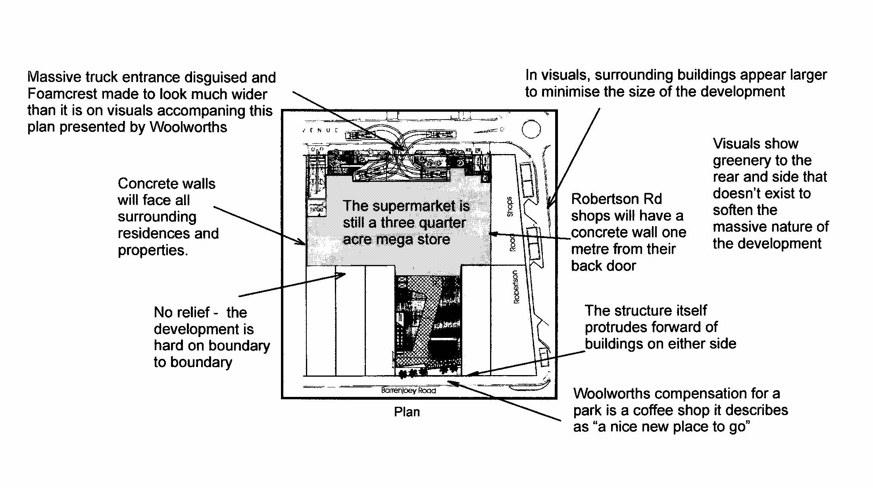
What are planning regulations for?

Put simply, our planning regulations are designed to ensure the best outcome for the local community both now and in the future, the community being made up of residents, businesses and local authorities.

In the present controversy, residents groups have only one basic request: that the north public carpark be retained for open green space with part of the south carpark sold to the developer.

Let’s imagine there was no deal in place with Woolworths and we were all looking at the possibilities for the site. In fact, in the preparation of the Masterplan, this is what happened.

Without the Council/Woolworths deal hanging over them, local people and planners talked about a Newport that would benefit the community- it would have open space, greenery, pedestrian links to other parts of Newport – in short would realise the wonderful potential of this beautiful little spot. Should we throw aside all those benefits now because a large corporation wants to build a huge supermarket on this land, of which they own only a portion?

If only some of the south carpark is sold to the developer, then any supermarket will be modest in size. We don’t want a mega store because it will dominate trade and kill local businesses. Our concern is that because Newport is a strip development, we need to do everything we can to offset that with an off main road village area.

If we don’t, Newport will become another tawdry traffic run, simply a grocery shopping destination for Woolworths, using our public carparking to strip profits out of the area for Woolworths head office.

Floor plan shows difference between Alternative and Woolworths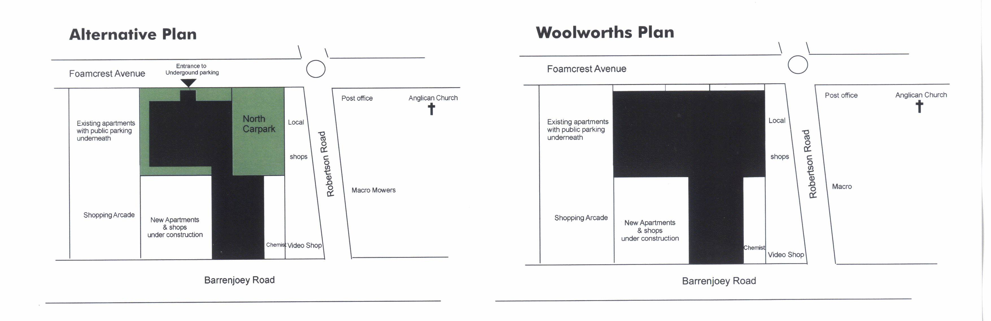

Our alternative plan would be taken up by most developers enthusiastically, yielding as it would almost 1.5 acres of floor area over 2.5 floors. Not only that, it would serve the business community as well with some residential, a modest supermarket that did not dominate local trade, and still give a return to the Pittwater Council in the form of rates and parking fees.

Local designer Nalin Perera’s visual interpretation of our alternative plan may be seen in the link below.

The Woolworths way

We’re getting sick and tired of the cynical approach taken by this greedy corporation. OK, they own a portion of land between our two parking lots and it’s a free country so they are free to build on their land.

But when they present visualisations of so called “concept” plans that appear to distort and spin, designed, we believe, to trick the local community and Pittwater Councillors to agree to the rezoning of our public land, we think enough is enough.

Don’t be fooled. Contract your local councillors to tell them to vote against rezoning so the community can sit down with the Council and the developer to work out a better solution for the future of Newport.

Links

Website: www.newportversuswoolies.org

Nalin Perera’s presentation of the alternative plan may be seen at http://www.newportversuswoolies.org/alternativeplan.htm

Facebook: http://www.facebook.com/#!/group.php?gid=110209982349741
Twitter: www.twitter.com/nowoolies

20th September 2009
19 Belinda Place,
Newport. NSW 2106,
20th September 2009,
Phone H. 99991030
Mobile 0409 395 102

Mr Stuart McDonald (Director)
and Mr Stuart Gordon (Senior Planner)
SJB Planning Pty Ltd,
Level 2, 490 Crown St
Surry Hills NSW 2010-05-13

Dear Mr McDonald & Mr Gordon,

Re Amended Pittwater Council Planning Proposal R0001/09 for rezoning of 17 and 25-27 Foamcrest Ave Newport.

I refer to the Hill PDA Economic Assessment dated 10th February 2010 and the peer review from Leyshon Consulting Pty Ltd dated April 2010 and believe you should note the following important facts and issues that flow from these two submissions,

- Definition of Trade Area – The definition ascribed to the primary trade area by Hill PDA we believe to be inaccurate and therefore misleading. Hill PDA define the primary trade area as that of being Newport and Bilgola and the secondary trade area being all other areas north of those to the end of the peninsula.

Access to and from Bilgola by its residents is either by Avalon or by Newport and anecdotally it is understood from discussions with Bilgola residents over 50% use Avalon as their closest village and it is their Barrenjoey Rd access point (Barrenjoey Rd being the only access road south off the Peninsula). Further the main road and access to Bilgola and all points north is via the ‘Bilgola bends’ on Barrenjoey Rd, a natural single lane choke point for all those areas north and a natural boundary.

Any argument to consider where on the peninsula another supermarket should be located has to take into account this natural piece of geography of the ‘Bilgola Bends’.

To put the total Bilgola population into Newport primary trade area we believe is misleading.

Irrespective of the above arguments the best and logical way to determine trade areas in the Pittwater Council area is to take the current Pittwater Council demographic definition of Ward area. Pittwater Council has broken it’s areas into three natural wards, that of the Northern Ward being Palm Beach, Whale Beach, Avalon, Clareville, Careel Bay and Bilgola, the Central Ward being Newport, Scotland Island, Church Point, the majority of Mona Vale, Bayview and part of Ingelside and lastly the Southern Ward being Warriewood, Elanora Heights, North Narrabeen and part of Mona Vale and part of Ingelside.

Newport is located in the Central Ward and is at the very southern end of the peninsula only three kms north of Mona Vale and is connected via a three lane main road in each direction (Barrenjoey Rd) thus allowing the residents of Newport easy and fast access to the large shopping areas of Mona Vale. The road converts to a single lane each way for all areas north of Newport. (still Barrenjoey Rd) which is the start of the Northern Ward.

- Population Densities as determinate of Supermarket needs –

The Hill PDA report floats between definitions of retail space and supermarket space depending on the slant they wish to make so it is difficult to draw direct comparisons between areas.

Hill PDA had drawn on the last census information published as at 2006 and this information is also available on the Pittwater Council Website. Unfortunately the Pittwater Website does not show the population by ward and on enquiry they have said they do not have this information. However by taking the census information via village from the Council web site plus the villages Council have nominated as primarily within specific wards, plus a review of the ward boundaries by street map we are able to reasonably estimate the populations by ward in 2006 as follows;

Ward
 | Village | Population census 2006 | Total Ward
North | Palm Beach, Whale Beach | 1,943
 | Avalon, Clareville, Careel Bay | 10,144
 | Bilgola, | 3,443 | 15,530
Central | Newport | 8,216
 | Scotland Island, Church Point etc | 1,860
 | Mona Vale (2.5k allowed to Sth Ward) | 7,008
 | Bayview | 3,015
 | Ingelside (Allow + 0.5k from Sth Ward) | 500 | 20,599
South | Mona Vale (from Central Ward) | 2,500
 | Warriewood/Ingelside (Ingelside allow -0.5K) | 5,439
 | Elanora heights | 3,923
 | Narrabeen North | 5,117 | 16,979
Total |  | #1 | 53,108
#1 Source Pittwater Council website 30.4.10

These 2006 population numbers have been estimated by Hill PDA to grow by 2016 to between 8% and 9% (despite the previous five year census period only showing a 0.6% increase in Newport). Using the Hill PDA estimates for the purpose of this evaluation we calculate the population densities for the Northern and Central Wards in 2016 as;

- Northern Ward - 17,393 persons
- Central Ward - 22,413 persons

Hill PDA note the current supermarket floor space in Newport at 1,932 sq m and at Avalon at 2,374 sq m. Hill PDA have not noted the supermarket floor space in Mona Vale (preferring to only use total retail area) however by accessing the various DA’s from the Pittwater Council website and by asking the supermarkets themselves we have determined the Mona Vale supermarket floor space at 11,025 sq m (Woolworths 4,400 sq m, Coles 3,925 sq m, Aldi 1,500 sq m and Thomas Dux [est.] 1,200 sq m). Therefore the sq m of supermarket space by ward is currently;

- Northern Ward - 2,374 sq m
- Central Ward - 12,957 sq m

Converting the above data into supermarket sq m by per person of population we arrive at the following numbers;

- Northern Ward - 0.136 persons per sq m
- Central Ward - 0.578 persons per sq m

This shows a clear bias already of supermarket space to the Central Ward. By adding another 3,000 sq m of floor space of supermarket in Newport as per the Woolworths rezoning submission it will increase the distortion of supermarket space in the Central Ward as follows;

- Northern Ward - 0.136 persons per sq m
- Central Ward - 0.711 persons per sq m

The above data shows that the justification to add additional supermarket space in Newport and the Central Ward is totally illogical based on population distributions. Whilst Hill PDA have attempted to hide this distortion by concentrating on economic spend by total retail area there is nonetheless a direct correlation between the economic spend and the actual population by area as the supermarket spend by person is the same in all areas.

Should there actually be any justification for additional supermarket floor space then one can see that by adding the proposed additional 3,000 sq m to the Northern Ward area the ratios would change to Northern Ward 0.309 person per sq m against the Central Ward of 0.578 person per sq m which would start to bring the two Wards closer together not further apart as recommended by Hill PDA on behalf of Woolworths.

Conclusion

- The above analysis shows there is no justification for the provision of additional supermarket space in Newport and absolutely NO justification for the two public owned carparks in Newport to be rezoned.

- Further we remind you that over 5,000 residents of Newport and the close areas have signed a petition and said they do not want or need a second supermarket in Newport. (On the basis of the altered concept plans we have taken into account the app. 2% of the petition signatories who indicated they may be satisfied with a second supermarket provided the carpark was placed underground and eliminated those from these numbers).

- We do not believe the peer review of the Hill PDA Economic report provided by Leyshon Consulting Pty Ltd adequately analysed these population and trade area facts but even give that, we remind you of their conclusion which says;

‘Finally, given the relatively close proximity of several existing Woolworths stores to Newport, it hardly could be said that the local community would be significantly advantaged in terms of supermarket provision by the project proceeding’.

We believe given these facts and the report of Leyshon you MUST bring in a report to Pittwater Council which recommends AGAINST the rezoning.

The writer would be more than happy to discuss the contents of this submission with you.

Yours sincerely,

Gavin R Butler
On behalf of the Newport versus Woolies committee

Copy: Mr. Andrew Piggott
Principal Strategic Planner
Pittwater Council
PO Box 882
Mona Vale NSW 1660

